Explain the purpose you feel your database serves and why you chose to build it specifically.
The purpose of the database is to provide individuals information regarding folk dancing clubs, districts, and instructors that are in Kansas. People who never have participated in folk dancing can use this database to find clubs and instructors that they can contact about getting more information on lessons. Folk dancing clubs can use this resource to find instructors. For example, if an instructor becomes ill, a club can use this database to find another instructor. Folk dancing districts can use this resource to know what clubs and instructors that exist in their area.
I built this this database to serve the Kansas folk dancing community. Lists and websites exist that provide information of instructors, clubs, and districts. However, no unified database or website exists. The lack of a database makes it difficult to find information. One website may list information regarding square dance clubs. To find information on round or contra dance clubs requires going to a different website. Although square, rounds, and contra dance websites may list some instructors, to find a complete list of instructors requires going to other websites. I designed this database to consolidate information that is spread across numerous websites. This should make it easier for interested parties to find the information they are looking for.
Explain your database design (aka, how you structured it, including the relationships of tables and fields).
The database has three tables: Clubs, Dance Districts, and Instructors. The Club table incorporates information regarding folk dancing clubs. This includes data such as location, address, who the dance instructor is, what dance district the club is part of, and more. The Dance Districts table contains information on the different districts in Kansas that includes who are on the boards for these associations. The Instructors table includes contact information and what dance types and levels each individual teaches. What connects the three tables to one another are Instructor_ID and Dance_District_ID. Instructor_ID in the Instructors table is connected to Instructor_ID in Clubs by a one-to-many relationship. Dance_District_ID in the Dance Districts table is connected to Dance_District_ID in the Clubs table by a one-to-many relationship. In the Instructors table, one will be able to see the clubs each instructor is associated to. In the Dance Districts table, one will be able to see which district clubs belong to.
Explain how you feel it could or should be implemented.
I think this database will work the best being incorporated into a Kansas folk dancing website. As stated earlier, the purpose of the database is to provide individuals information on clubs, districts, instructors, and more. The user can be anyone from someone who is interested in folk dancing lessons to the boards of the Kansas dance districts. Being online will allow the database to reach the most people possible. Furthermore, clubs, instructors, districts, or association can incorporate the link into their websites. For example, the Kansas Square Dance Association (KSDA) could print out reports from this database for their webpages on the clubs, districts, and instructors. KSDA could then provide a link to database. Depending on how often KSDA updates their website, the link will allow users to confirm the information is correct. Square dance clubs can use the information in this database to make list of substitute instructors incase their instructor ever get ill. The database is designed to be a steppingstone. The purpose is to provide interested parties, regardless of who they may be, the contact information of the district, club, or instructor that can best assist them.
Explain your design (aka, look and feel for the end user; a screen shot of the form and report could be useful here) and your reasons for it.
When the database was designed, simplicity was kept in mind. For example, the District Clubs report (see Figure 1). In Kansas, there are two folk dancing districts: Blue and Gold. Kansas clubs belong to one of these two districts. Underneath the District field is the Club Name. Clubs are listed alphabetically. The location and address for the clubs are provided. The following club information is shaded in a different color than the preceding club. This should help the reader to easily see what information belongs to what club. I think the simplicity of this reports help the user to see what clubs belong to what district and what address belongs to what club.
The form incorporates simplicity like the report (figure 2). I think each field is self-explanatory. Furthermore, I think all the fields that are needed are incorporated. The address, phone numbers, and email fields allow the user to see the contact information. The Dance_Types field informs the user what type of dances this individual instructs. The Dance_Levels field allows the user to know what levels the instructor can teach. The simplicity of the form should help prevent confusion when information is added.
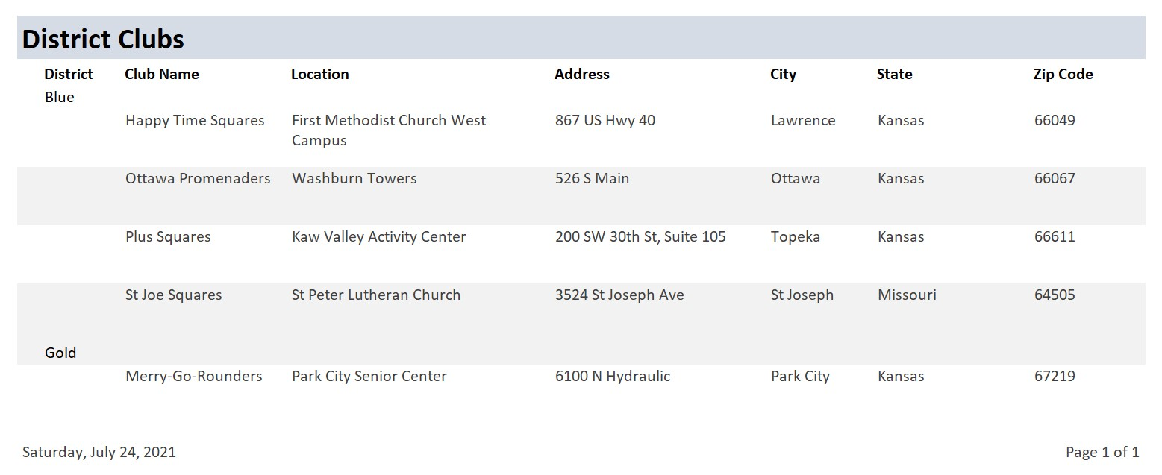
Figure 1
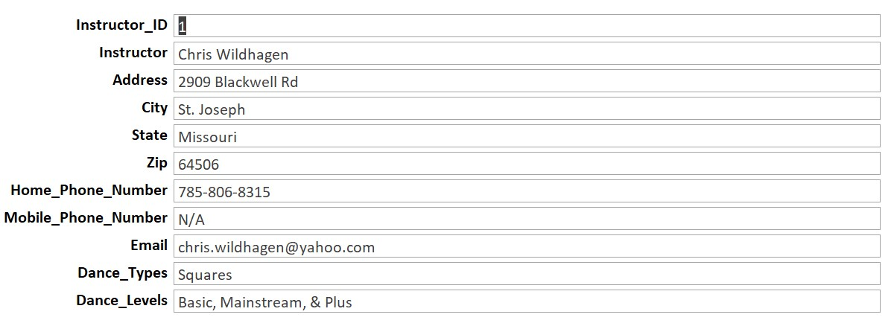
Figure 2

