DB Directions
For the Kansas Folk Dancing database

Field definitions:
The fields for the tables and forms. Some fields may show up on reports.

Clubs (see Club Form and Club Table)
- Club_ID: Number assigned to the club. When a new club is added to the table, a new number is added (e.g., if the last club # is 8, the new club # will be 9).
- Club_Name: The name of the dance club
- President: The name of the individual who oversees the club
- Instructor_ID: The Instructor_ID number (found in Instructors)
- Dance_District_ID: The Dance_District_ID number (found in Dance Districts)
- Location: The location where the club meets
- Address: Address of the location
- City: The city where club meets
- State: The state the location is in
- Zip_Code: Zip of the location
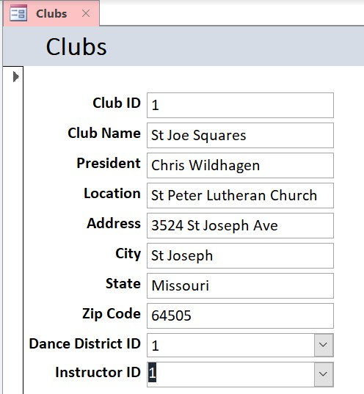
Club Form

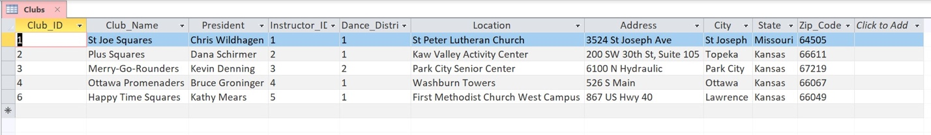
Club Table

Dance Districts (see Dance District Form and Dance District Table)
- Dance_District_ID: NOTE, two dance districts exist in Kansas. Blue (1) and Gold (2). This field probably will never need to be changed.
- District: Name of district.
- President: Name of individual(s) in this position
- Vice_President: Name of individual(s) in this position
- Secretary: Name of individual(s) in this position
- Treasurer: Name of individual(s) in this position
- Historian: Name of individual(s) in this position
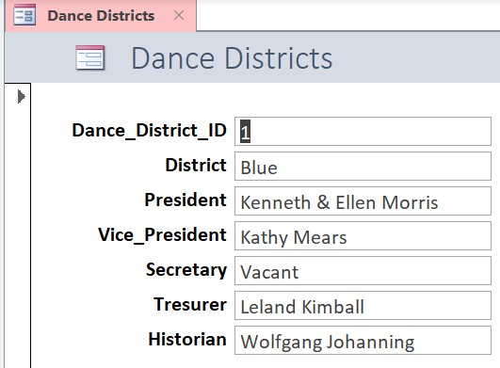
Dance District Form
Dance District Table

Instructors (see Instructor Form and Instructor Table)
- Instructor_ID: Number assigned to the instructor. When a new instructor is added to the table, a new number is added (e.g., if the last instructor # is 8, the new instructor # will be 9).
- Instructor: The name of the instructor
- Address: The address of the instructor
- City: The city the instructor lives in
- State: The state the instructor lives in
- Zip: Zip of the area the instructor lives in
- Home_Phone_Number: Home phone number of the instructor. Input as XXX-XXX-XXXX
- Mobile_Phone_Number: Mobile phone number of the instructor. Input as XXX-XXX-XXXX
- Email: Email of instructor
- Dance_Types: The types of dances the instructor teaches (e.g., squares, lines, rounds, contras, clogging)
- Dance_Levels: The dance levels the instructor teaches (e.g., Basic, Mainstream, Phase I, Phase II)
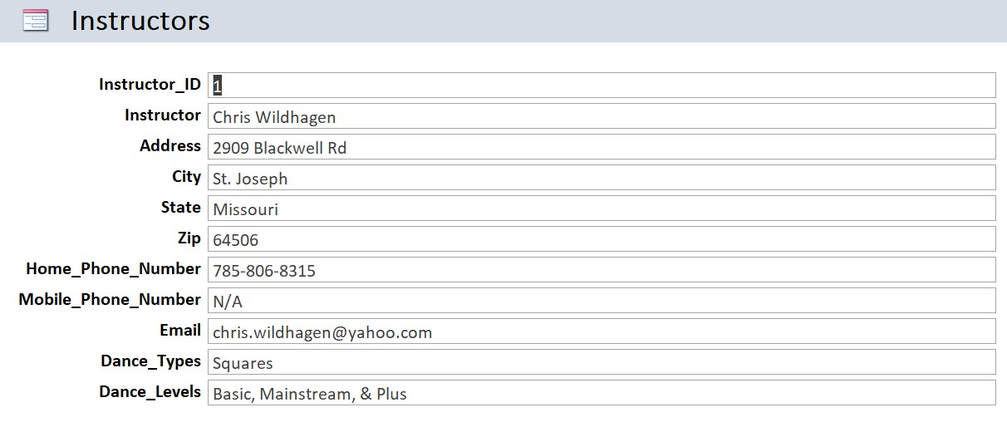
Instructor Form
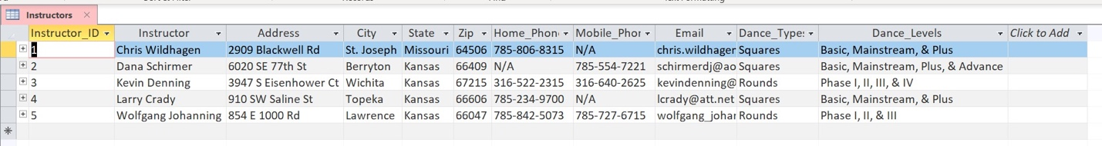
Instructor Table

Database Usage
Data (Figure D.1)
- Data input (From my experience, it is the best to add new data using the tables function.)
  - To add new data, select the appropriate table
  - Select “New Record” or go to the bottom of the table
  - Fill in the applicable fields
  - Save data
- Data modification (From my experience, it is the easiest to modify data in the tables function. However, it can also be done by the forms function.)
  - Select the appropriate table or form
  - Select the field of the data one wants to change
  - Change data
  - Save changes
- Data deletion (From my experience, deleting one field of data can be done either in the tables or forms. Deleting an individual, club, or district is probably best done in the tables).
  - Select the appropriate table or form
  - Select the field or fields one wants to delete
  - Delete data
  - Save changes
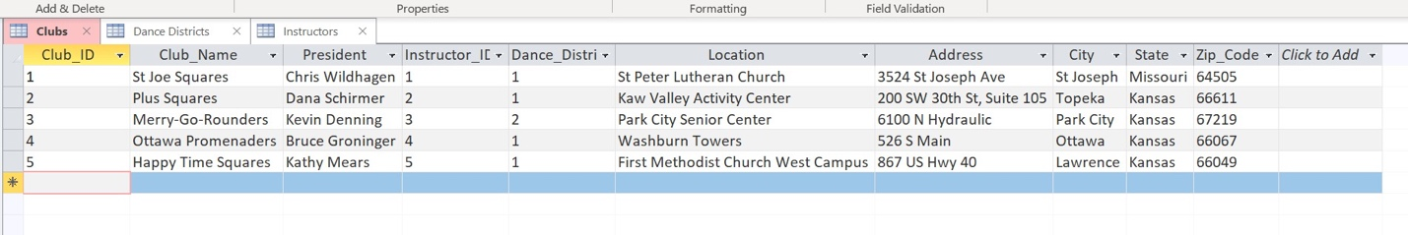
Figure D.1
Fields (See Figure F.1)(From my experience, it is best to do this in the tables function.)
- Field input
  - Select the appropriate table
  - Select “Insert Field,” “Click to Add” or like button
  - Name the field
  - Save changes
- Field modification
  - Select the appropriate table
  - Select “Rename Field” or the like
  - Rename the field
  - Save changes
- Field deletion (Note: deleting a field may delete all the data in that field)
  - Select the appropriate field
  - Select “Delete Field”
  - Delete field
  - Save changes
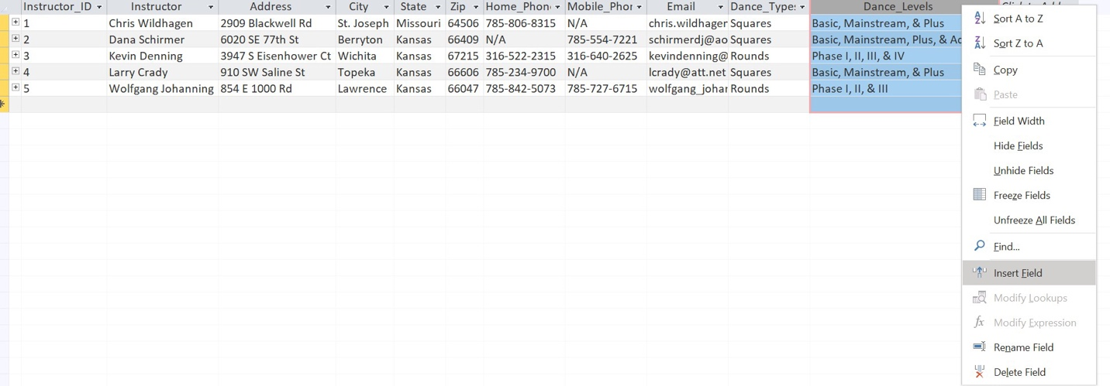
Figure F.1

Reports
- Preexisting reports (e.g., District Clubs) can be found underneath the Reports tab. Any changes done on the tables and forms should automatically update on the reports.
- If the preexisting reports are not sufficient, reports can be created. One clicks on the Create Report and select the applicable fields and how one wants the data to be presented.

Notes
- Instructor_ID and Dance_District_ID fields were used to form relationships between the tables Instructors, Clubs, and Dance Districts (see Figure R.1).
  - When creating a new record, it is best to fill this field first.
  - Be careful with these fields (as well as Club_ID). The numbers in these fields are used to identify a particular club, instructor, or district. If changing a number in this field, it is best to make sure that number is changed on the other tables as well.
  - When changing or deleting data in these fields, error or change messages may appear. I have found that sometimes it is best to only have the table one is currently using and have all the others closed.
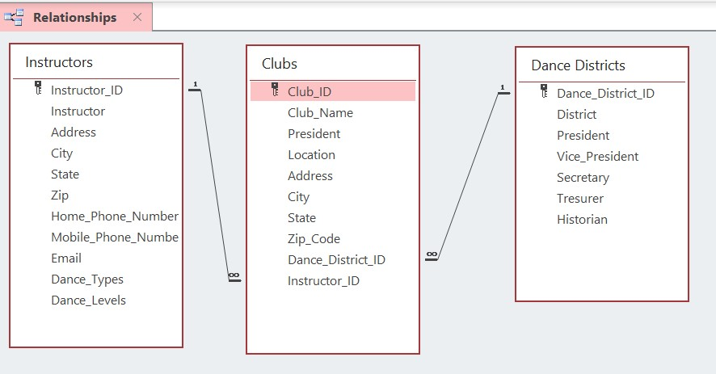
Figure R.1

